Whether or If-Clause as a Verb Complement

✅ What Is a Whether/If-Clause as a Verb Complement?
# Source: AI Source: Provided by: [Data Path: Persons Table -> ID Column: 1, Name_En Column: Motasem Essam] -> From: [ChatGPT] on [8/4/2025]
A whether/if-clause is a dependent noun clause introduced by “whether” or “if”, used to express uncertainty, possibility, or indirect yes/no questions. It serves as a verb complement by completing the idea of the main verb.

🔸 Structure:
# Source: AI Source: Provided by: [Data Path: Persons Table -> ID Column: 1, Name_En Column: Motasem Essam] -> From: [ChatGPT] on [8/4/2025]
- Verb + whether/if + clause
- Common after verbs like: know, wonder, ask, doubt, find out, decide, etc.

🔸 Examples:
# Source: AI Source: Provided by: [Data Path: Persons Table -> ID Column: 1, Name_En Column: Motasem Essam] -> From: [ChatGPT] on [8/4/2025]
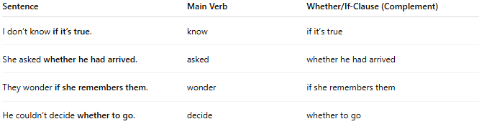
Sentence | Main Verb | Whether/If-Clause (Complement)
I don’t know if it’s true. | know | if it’s true
She asked whether he had arrived. | asked | whether he had arrived
They wonder if she remembers them. | wonder | if she remembers them
He couldn’t decide whether to go. | decide | whether to go

🔸 Why It's a Verb Complement:
# Source: AI Source: Provided by: [Data Path: Persons Table -> ID Column: 1, Name_En Column: Motasem Essam] -> From: [ChatGPT] on [8/4/2025]
These clauses answer the indirect yes/no question posed by the verb, making the sentence semantically complete.
🟢 Example:
- ✅ "I wonder if he’ll come." (complete)
- ❌ "I wonder." (incomplete – wonder what?)

